**Course _______Specialist_____ Year ___12_____**

Student name: ________________ Teacher name: ________________

**Task type: Response**

**Time allowed for this task: ____40_______ mins**

**Number of questions: _____7______**

**Materials required:** Calculator with CAS capability (to be provided by the student)

Standard items: Pens (blue/black preferred), pencils (including coloured), sharpener, correction fluid/tape, eraser, ruler, highlighters

Special items: Drawing instruments, templates, notes on one unfolded sheet of   
A4 paper, and up to three calculators approved for use in the WACE examinations

**Marks available: ___38___ marks**

**Task weighting: _10___%**

**Formula sheet provided: Yes**

**Note: All part questions worth more than 2 marks require working to obtain full marks.**

Q1 (2, 2 & 3 = 7 marks) (3.1.1 to 3.1.3)

If  &  determine the following.

1. 
2. 
3. 

Q2 (3 marks) (3.1.2)

Determine all possible pairs of real numbers  such that 

Q3 (2 & 3 = 5 marks) (3.1.13- 3.1.15)

Consider the function .

1. Determine the remainder of  when divided by .
2. Show that  is a factor of and hence determine all linear factors.

Q4 (3 marks) (3.1.9)

Determine the complex number  in the form  with  & .

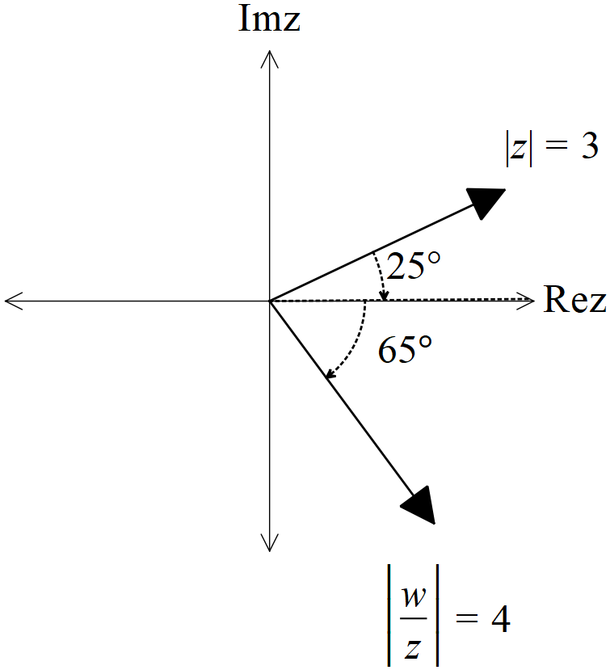

Q5 (2, 2, 3 & 3 = 10 marks) (3.1.10)

Consider the following set of complex numbers  such that .

Determine the following.

1. Minimum value of . (exact)
2. Maximum value of . (exact)
3. Maximum value of Arg in radians to two decimal places.
4. Maximum value of  (exact)

Q6 (3 & 3 = 6 marks) (3.1.6)

Let  be complex numbers such that



1. Determine the exact value of Arg() in principal form (i.e )
2. Determine the exact value of 

Q7 (4 marks) (3.1.10)

Sketch the locus of complex numbers that satisfy **both** of the following

 **AND**  in the Argand diagram below.

